Name: PRATIK SUNIL ABHANG
Registration ID: 260640160209

Question 1
Create employees.txt and add the given data. Then perform the following grep operations.

Commands
touch employees.txt
nano employees.txt
cat employees.txt

Employee Data
101 Amit IT Pune 55000
102 Sneha HR Mumbai 48000
103 Rahul Finance Pune 62000
104 Priya IT Bangalore 58000
105 Karan Sales Delhi 45000
106 Neha IT Pune 67000
107 Ankit HR Pune 52000
108 Pooja Finance Mumbai 61000
109 Rohan Sales Pune 49000
110 Meera IT Hyderabad 70000
111 Suresh HR Bangalore 53000
112 Kavita Finance Delhi 65000
113 Vivek IT Pune 60000
114 Anjali Sales Mumbai 47000
115 Mohan IT Delhi 59000
116 Pratik IT Pune 68000
117 Aditi HR Mumbai 54000
118 Shital Finance Nashik 63000
119 Falguni Sales Nagpur 51000
120 Prathmesh IT Pune 66000

1. Display all employees who work in the IT department.
Command:
grep "IT" employees.txt
Answer:
Displays all IT department employees.
Output:

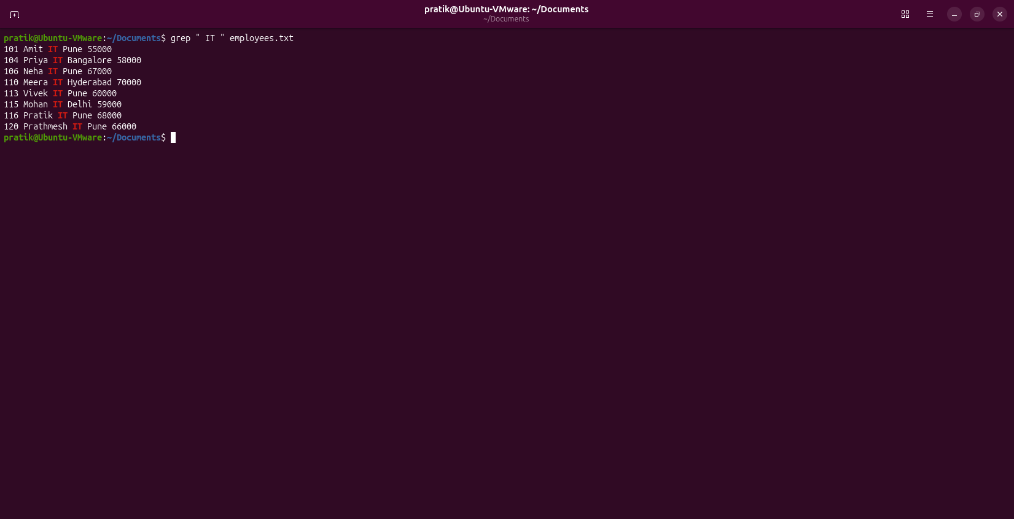2. Display all employees located in Pune.
Command:
grep "Pune" employees.txt
Answer:
Displays all employees from Pune.
Output:

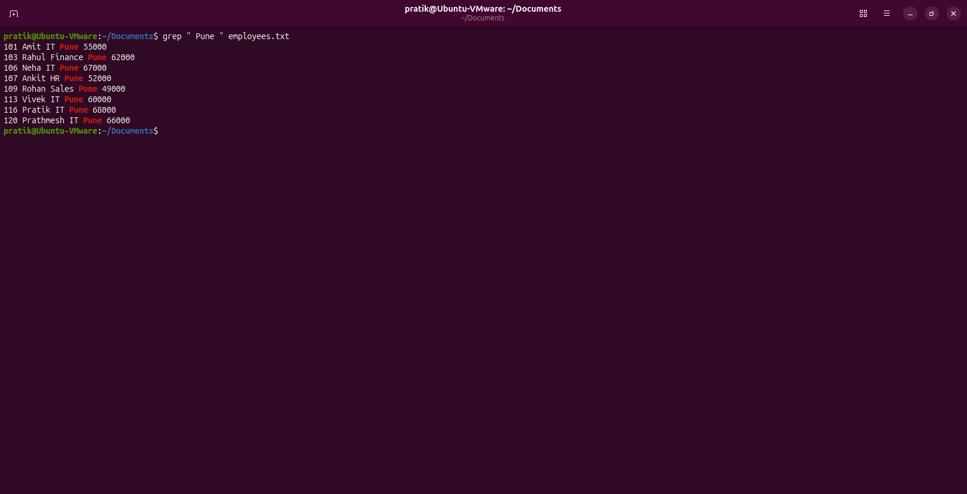3. Display all employees whose name starts with the letter A.
Command:
grep -E '^[0-9]+ A' employees.txt
Answer:
Displays employee names starting with A.
Output:

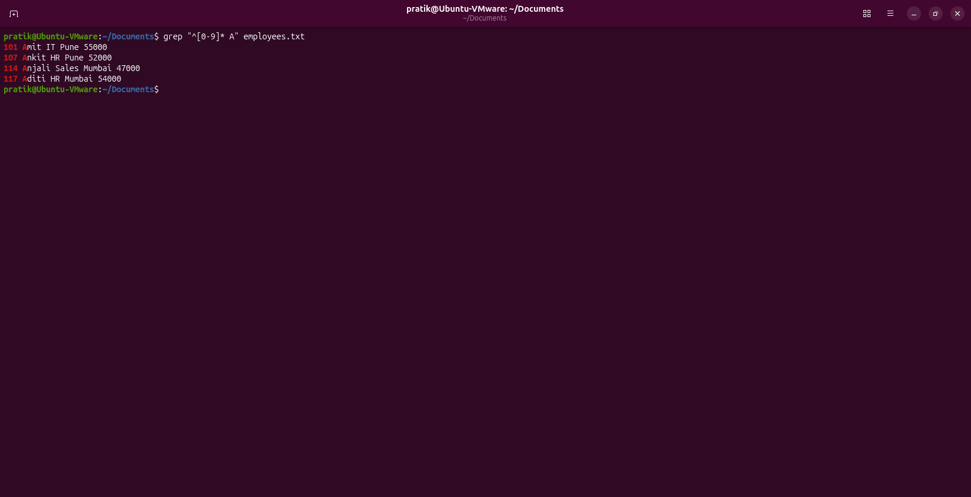4. Find all employees whose salary contains digit 7.
Command:
grep -E '[0-9]*7[0-9]*$' employees.txt
Answer:
Displays salaries containing digit 7.
Output:

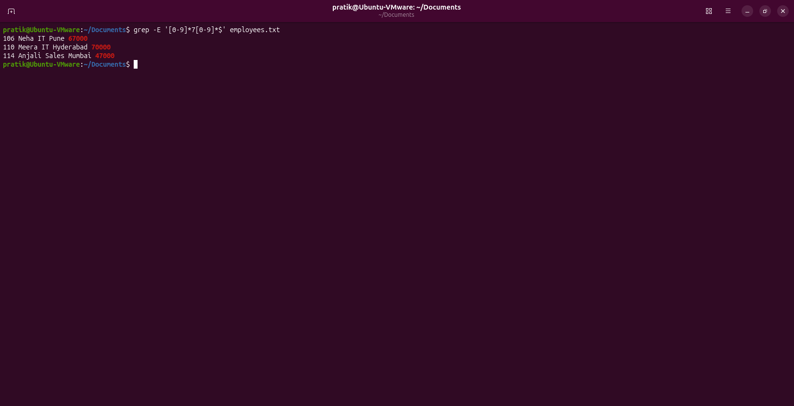5. Display line numbers with HR employees.
Command:
grep -n "HR" employees.txt
Answer:
Displays HR employees with line numbers.
Output:

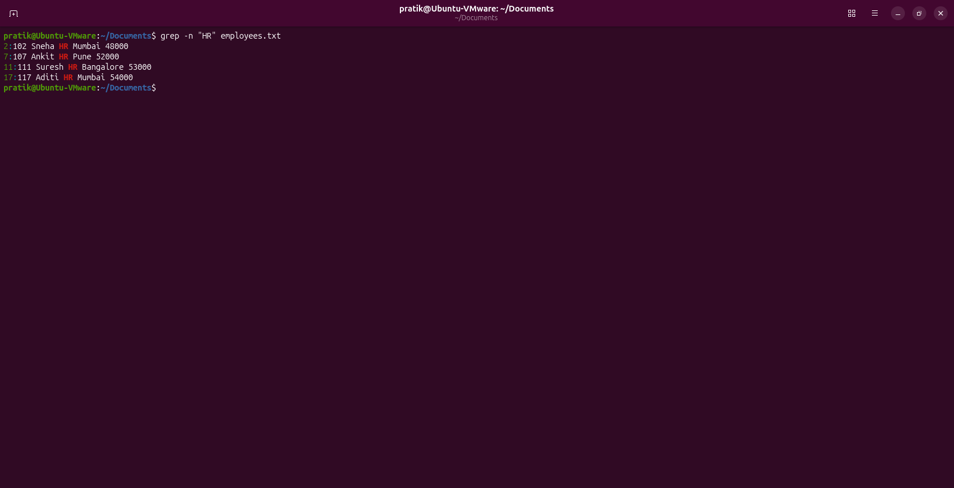6. Count Finance employees.
Command:
grep -c "Finance" employees.txt
Answer:
Counts Finance employees.
Output:

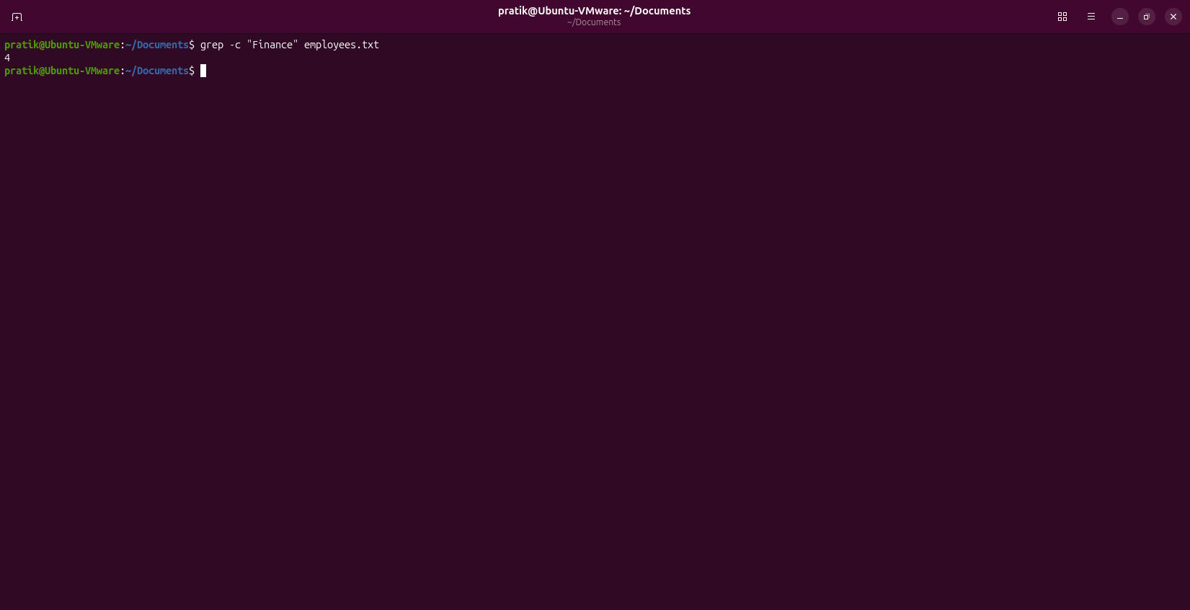7. Display all employees except Sales.
Command:
grep -v "Sales" employees.txt
Answer:
Displays non-Sales employees.
Output:

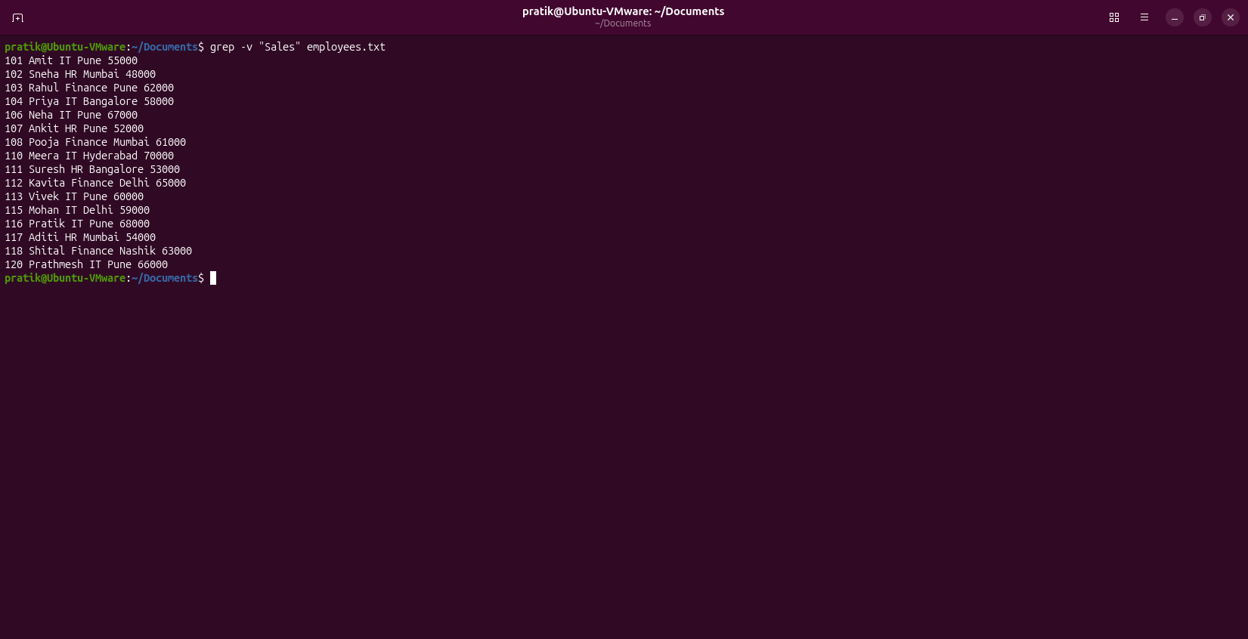8. Display only names of Mumbai employees.
Command:
grep "Mumbai" employees.txt | awk '{print $2}'
Answer:
Displays only employee names.
Output:

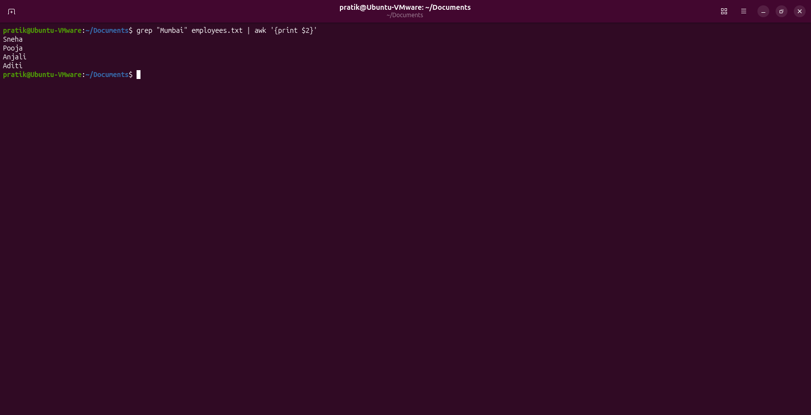9. Display employees with salary 60000 or above.
Command:
grep -E '(6[0-9]{4}|[7-9][0-9]{4}|[1-9][0-9]{5,})$' employees.txt
Answer:
Displays employees with salary >=60000.
Output:

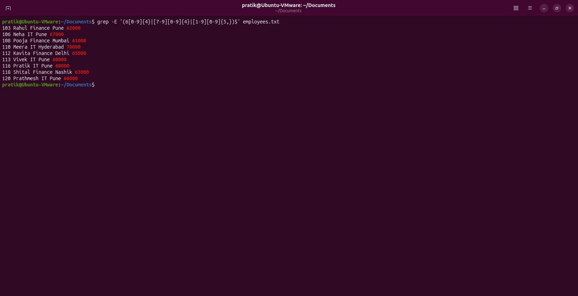10. Search IT ignoring case.
Command:
grep -iw "IT" employees.txt
Answer:
Case-insensitive IT search.
Output:
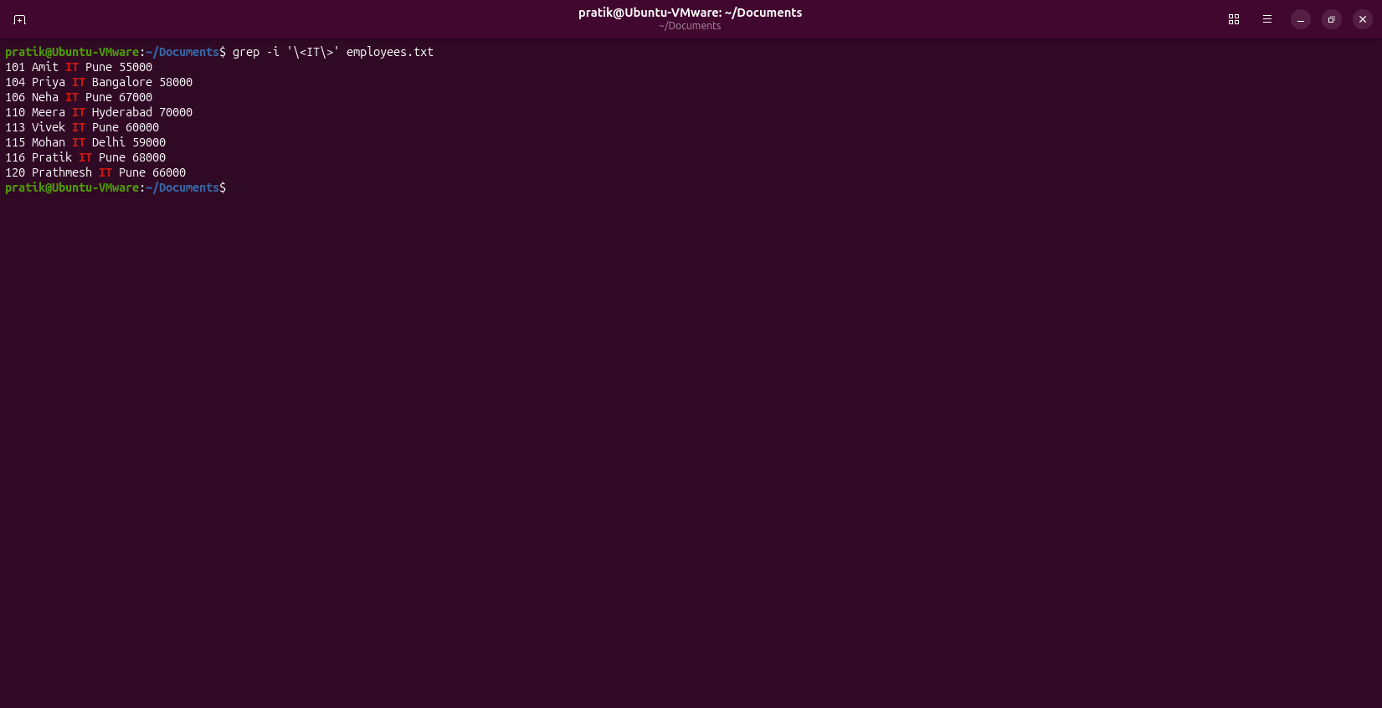

Q2
Question:
Display all files including hidden files in long listing format.
Command(s):
ls -la
Answer:
Displays all files including hidden files.
Output:
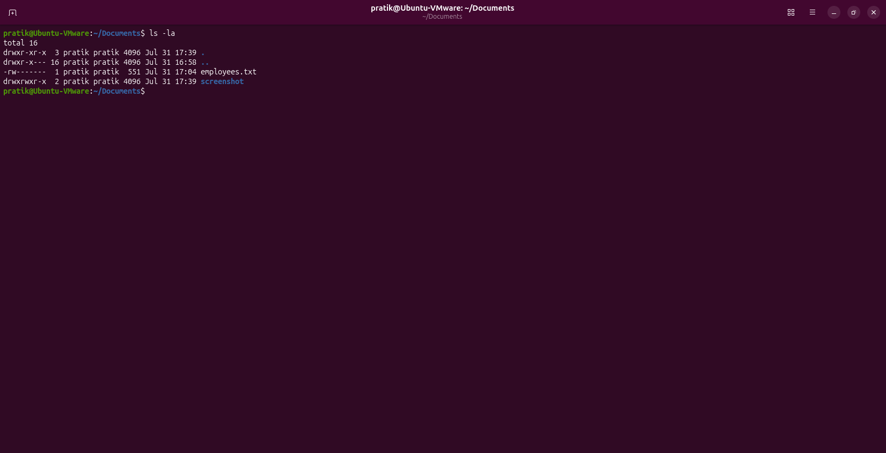

Q3
Question:
List files sorted by newest first.
Command(s):
ls -lt
Answer:
Lists files by modification time.
Output:
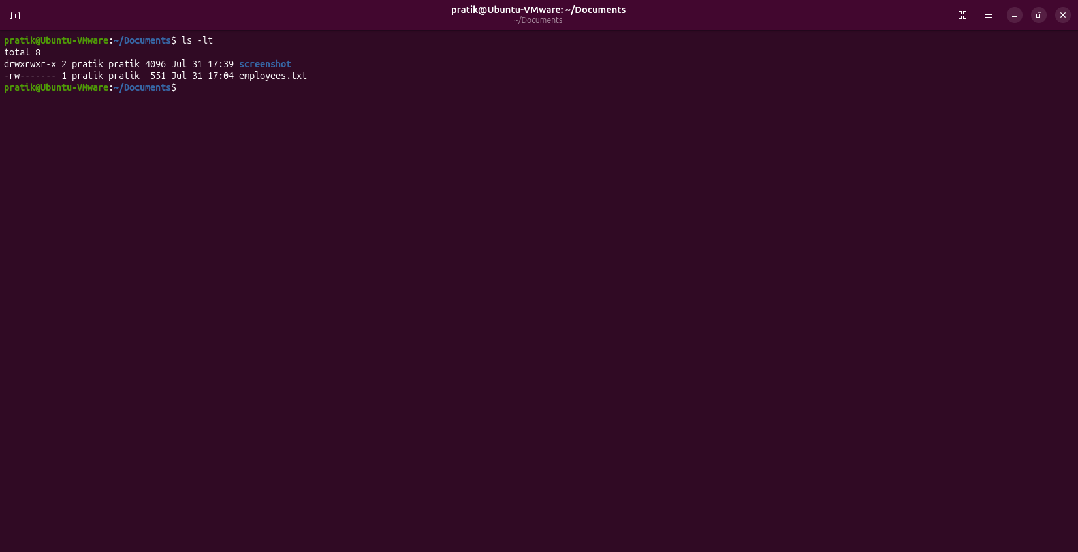

Q4
Question:
Display only directories.
Command(s):
ls -d */
Answer:
Shows only directories.
Output:
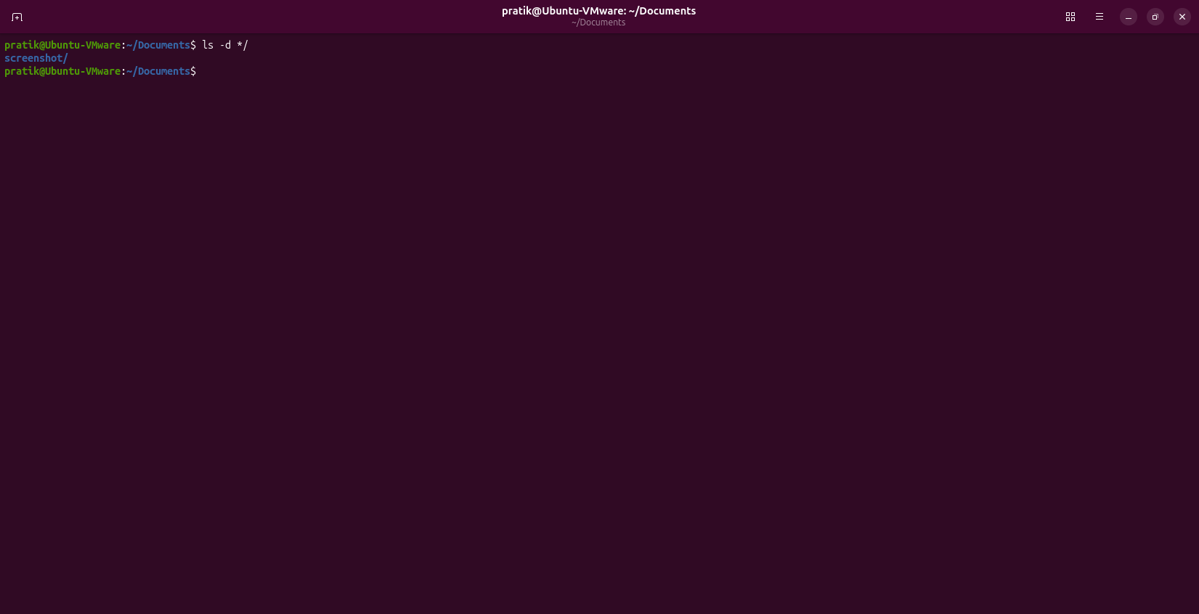

Q5
Question:
List files in reverse alphabetical order.
Command(s):
ls -r
Answer:
Lists files in reverse order.
Output:


Q6
Question:
Display human-readable sizes sorted largest first.
Command(s):
ls -lhS
Answer:
Shows file sizes sorted descending.
Output:
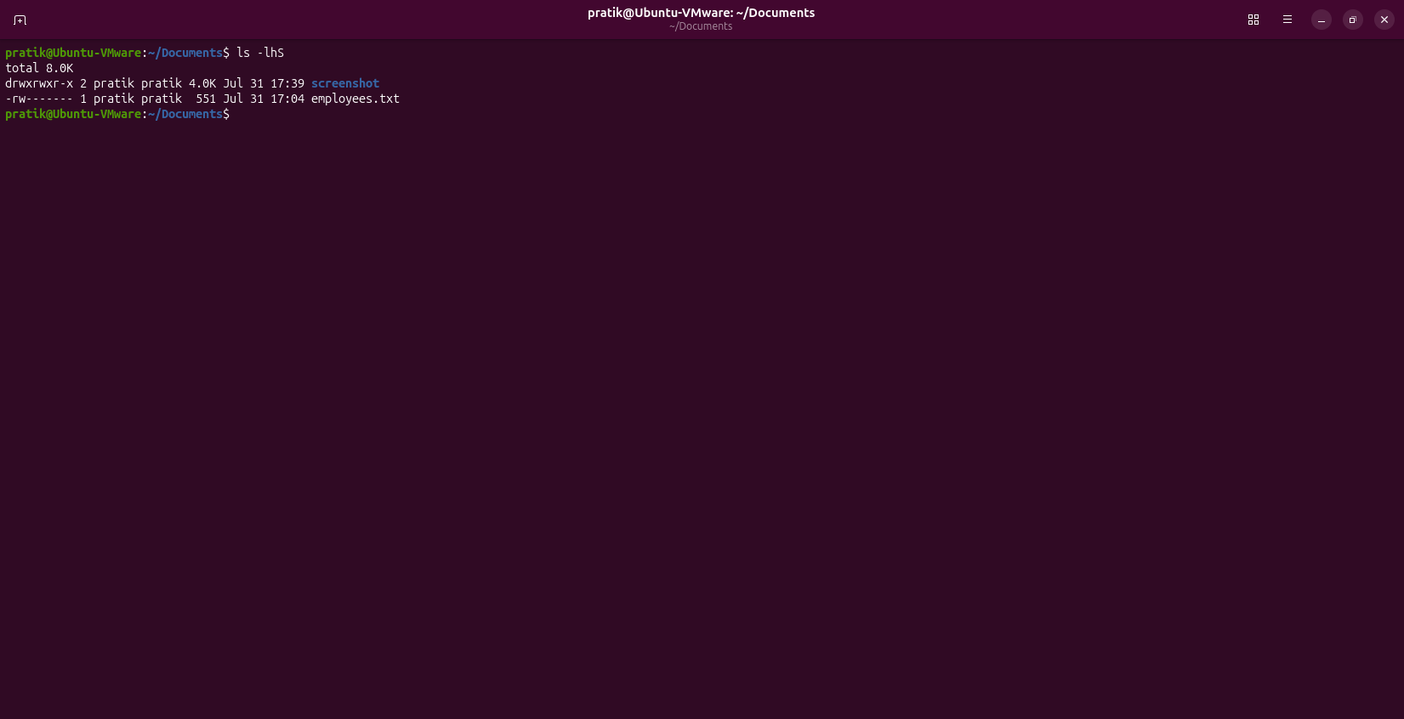

Q7
Question:
Stop one process, continue another and verify.
Command(s):
sleep 1000 &
sleep 2000 &
ps
kill -STOP <PID1>
kill -CONT <PID2>
ps -o pid,stat,cmd -p <PID1>,<PID2>
Answer:
Stops and resumes processes.
Output:
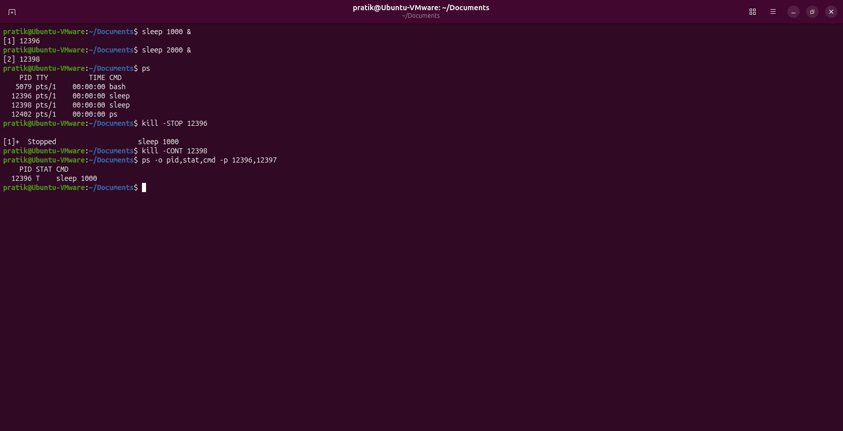

Q8
Question:
Kill only one process among multiple similar processes.
Command(s):
sleep 5000 &
sleep 5000 &
sleep 5000 &
ps aux | grep sleep
kill <PID>
ps aux | grep sleep
Answer:
Terminates selected process.
Output:
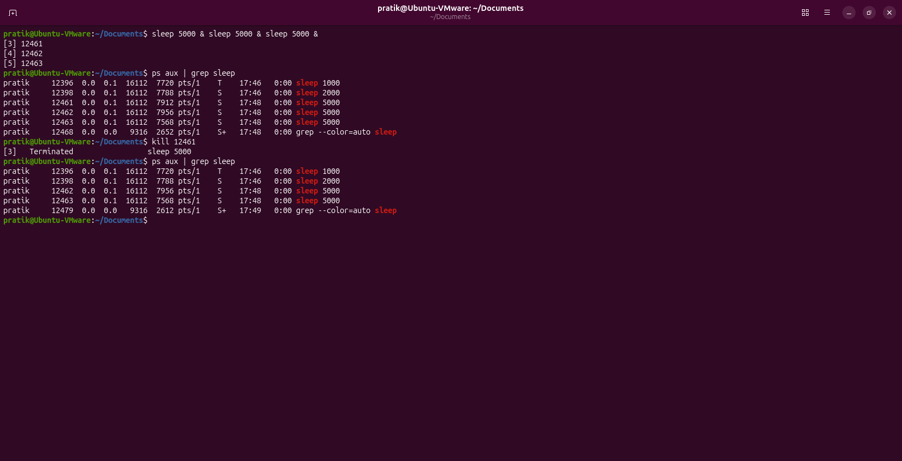

Q9
Question:
Terminate a stopped process.
Command(s):
sleep 2000
# Press Ctrl+Z
jobs
kill %1
kill -9 %1
jobs
ps -p <PID>
Answer:
Terminates stopped job.
Output:
